**Lecture 8**

**ALTERNATING SERIES. ABSOLUTE AND CONDITIONAL CONVERGENCE**

ALTERNATING SERIES

Series whose terms alternate between positive and negative, called alternating series, are of special importance. In general, an alternating series has the following form:

 (1)

*where* 

The following theorem is the key result on convergence of alternating series.

T**heorem (*Alternating Series Test*)** *An alternating series of form* (1) *converges if the following two conditions are satisfied:*

1.  (2)
2.  (3)

*Proof* .The idea of the proof is to show that if conditions (*a*) and (*b*) hold, then the sequences of even-numbered and odd-numbered partial sums converge to a common limit *S*. It will then follow from Theorem that the entire sequence of partial sums converges to *S*.

Figure 1 shows how successive partial sums satisfying conditions (a) and (b) appear when plotted on a horizontal axis.

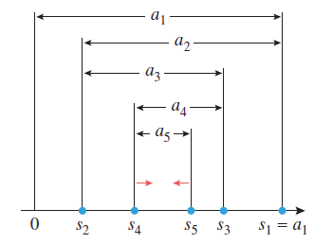

Figure 1

The even-numbered partial sums

, , ...,

.

form an increasing sequence bounded above by *a*1, and the odd-numbered partial sums

, , ..., , …

form a decreasing sequence bounded below by 0. Thus the even-numbered partial sums converge to some limit SE and the odd-numbered partial sums converge to some limit SO. To complete the proof we must show that SE = SO.

We can write

.

So that

.

which completes the proof.

**1-мысал**. Use the alternating series test to show that the following series converge .

Шешуі. General term is . The two conditions in the alternating series test are satisfied since  and 

**2. Absolute convergence**

The series



does not fit in any of the categories studied so far—it has mixed signs but is not alternating.

We will now develop some convergence tests that can be applied to such series.

**Definition.** A series

 (4)

is said to ***converge absolutely*** if the series of absolute values

 (5)

converges and is said to ***diverge absolutely*** if the series of absolute values diverges.

**Theorem 1.** *If the series (5) converges, then so does the series (4).*

**Conditional convergence**

Although Theorem -1 is a useful tool for series that converge absolutely, it provides no information about the convergence or divergence of a series that diverges absolutely. For example, consider the series

 (6)

These series diverge absolutely, since the series of absolute values is

the divergent harmonic series



However, series (6) converges, since it is the alternating harmonic series.

As a matter of terminology, a series that converges but diverges absolutely is said to ***converge conditionally*** (or to be ***conditionally convergent***). Thus, (6) is a conditionally convergent series.

**Theorem (*Ratio Test for Absolute Convergence*).** *Let be a series with nonzero*

*terms and suppose that*



(*a*) *If l <* 1*, the series converge absolutely and therefore converges.*

(*b*) *If l >* 1 *or l* = *, the series  diverges.*

(*c*) *If l* = 1*, no conclusion about convergence or absolute convergence can be drawn*

*from this test.*